Is a living wage feasible in Tompkins County?

Reed Eaglesham, Ian Greer, Sean O’Brady, Shaianne Osterreich, Maru Rodriguez, and Russell Weaver

August 2022

Below we describe our research, summarize our results, and raise what we expect to be the critical questions of any discussion of bringing the minimum wage up to the living wage.

Our research took place in response to the widespread concern that wages were not keeping up with the cost of living. In upstate New York, minimum wages rose in a planned and transparent manner between 2016 and 2021 from $9.60 to $13.20. Alternatives Federal Credit Union produces a living wage calculation based on data on the cost of living. This Living Wage (LW) is normally calculated for Tompkins County every two years, based on prices for rent, food, transportation, communication, recreation, savings and miscellaneous houseware/clothing items. For full-time employees between 2015 and 2022, AFCU’s headline figure rose from $13.77 to $16.61 (although it is lower for workers whose employers provide health insurance. calculation is $3.42 more than the minimum wage.

In 2018, then Tompkins County Legislators Leslyn McBean-Clairborne and Anna Kelles, in collaboration with the Tompkins County Workers’ Center Director Pete Meyers, convened the Tompkins County Livable Wage Working Group (TCLWWG). The group included representatives from local business, unions, non-profit agencies, and social services. There were also researchers from Cornell University’s School of Industrial and Labor Relations and Ithaca College’s Economics Department. The group’s goal was to uncover the challenges and opportunities that would come from county-level legislation that would require the minimum wage to be equal to the livable wage, in other words to find out whether LW legislation was “feasible”.

Over several months the working group held many structured information gathering sessions with businesses and workers. The research sub-group carried out several projects to learn more about current conditions for workers and businesses in the county. This included doing analysis of labor market data, mainly based on American Community Survey 5-year estimates; detailed simulations of the impact that raising wages would have on eligibility for public benefits; and two waves of employer interviews (2019 and 2021).

Tompkins County has the highest level of income inequality in upstate New York. Our analysis of gives a clear indication of who would benefit from a substantial minimum wage increase.
- More than one-third of workers in Tompkins County earn effective hourly wages below the LW. 35.2% effectively earned less than $15.32 per hour (in 2020 dollars) and 39.7% earned less than $16.61 per hour.
- The likelihood of earning below a LW in Tompkins County is strongly associated with a worker’s race-ethnicity. Depending on which LW threshold is used ($15.32 or $16.61), between 68% and 74% of Black workers fail to earn a LW in Tompkins County, compared to 32% and 36% of white workers. Workers who identify as Asian, Hispanic/Latinx, or with some other racial-ethnic group(s) earn below a LW at rates that are at least ten percentage points higher than white workers. See the figure below.
- Low-wage work is extremely common in the hospitality, food services, and retail sectors, where 67-71% of workers earned less than the LW. However, the county’s largest sectors, education services and healthcare also employ large numbers of low-wage workers.
- Benefits cliffs are real and would affect about 2% of the low-wage workforce. These workers and their families risk losing some of their Medicaid, SNAP, or other means-tested benefits if the minimum wage goes up. The numbers would be smaller if they reduced their working time or if benefits were reformed to allow more earned income.

Employers would pay the cost of any minimum wage increase. To understand the impact on employers, we developed a methodology and a structured questionnaire which was approved by the TCLWWG. In the first round of interviews with 40 employers (2019) we asked questions about demographics, experiences with past minimum wage increases, cost of an increase to living wage calculation, different channels of adjustment, and overall opinion about the living wage proposal. In the second round (2021) we also asked 32 of the same employers about pandemic challenges, wage compression, wage setting policy, and adaptive capacity. The sample included the largest employers, the major sectors employing low-wage workers, and nonprofit health and social services agencies; within each group we sought a mixture of LW and sub-LW employers.
- Employers had varying views of LW legislation, although a majority were in favor. Large organizations were more likely to oppose it than smaller ones, and some of the employers who opposed legislation in 2019 supported it in 2021.
- Employers had varying assessments on the expense of paying a LW. For most employers it was difficult to provide a clear calculation of the cost, and the three employers that did cost it out for us did so in different ways.
  - For some it was merely a matter of increasing pay, benefits, and payroll taxes for workers below the LW threshold.
  - For others it was also a matter of addressing “compression”, to maintain pay differences between entry-level and experienced workers.
  - Some employers pointed out that the cost is uncertain, because it remains to be seen how effectively they could adapt, i.e. increase revenue or become more efficient.
If the county legislature decides to act on the LW proposal, the employer interviews suggest some critical questions that will inevitably be discussed.
- Many employers believe that they cannot afford to pay a LW, but others see this issue differently. The more fundamental issue may be how to help organizations adapt. A clear timeframe, financial support, and consulting expertise were all suggested as possible ways policymakers could help.
- How unfair is wage compression? The vast majority of employers – even some that supported the LW proposal – were concerned that reducing pay differentials would be seen by experienced workers as unfair. We know less about worker views, but we expect that minimum wage increases do create more compressed pay structures.
- Would certain workers be excluded from LW legislation? Higher education institutions may push back against applying LW legislation to student workers, because they see it in terms of student aid for middle-class families. Restaurants, bars, and cafes would oppose applying the living wage to tipped workers, because they see tips as an important work incentive. There is also a widespread view among employers that the LW should not apply to new hires during their probationary period.

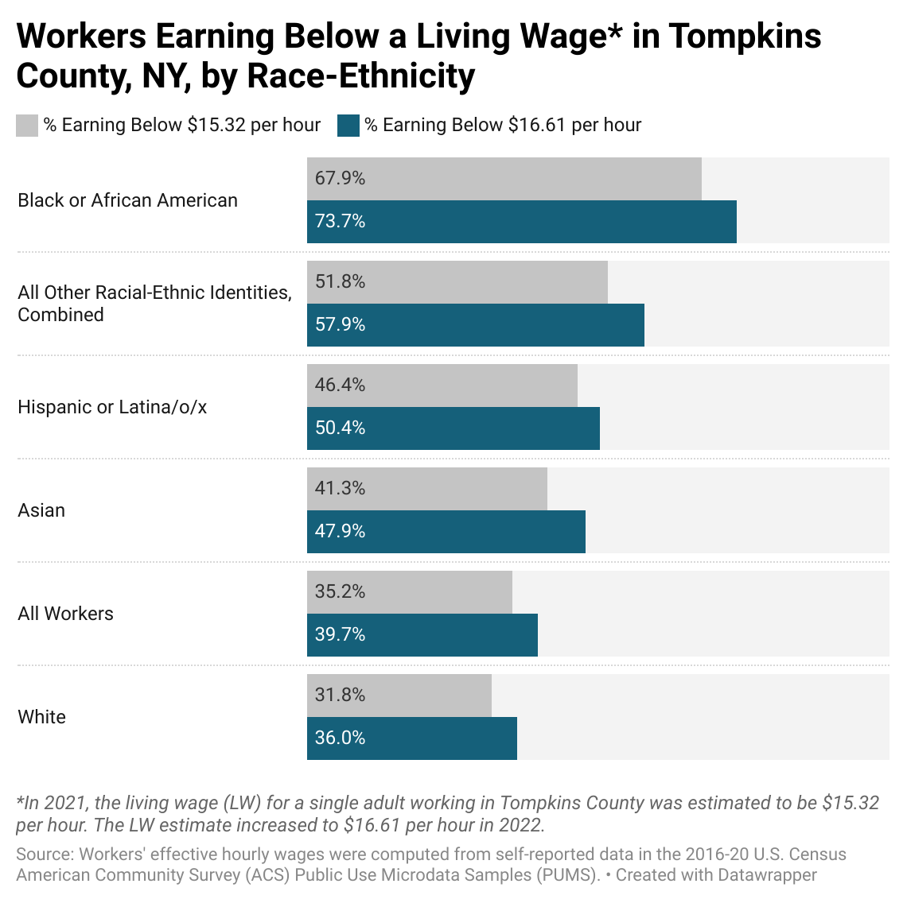

https://www.ny.gov/new-york-states-minimum-wage/new-york-states-minimum-wage
https://www.alternatives.org/about/impacting-our-community/living-wage-study.html
Abel, Jaison R., and Richard Deitz. "Why are some places so much more unequal than others." Federal Reserve Bank of New York Economic Policy Review 25.1 (2019): 58-75.
In 2021, the living wage (LW) for a single worker in Tompkins County was estimated to be $15.32 per hour. That number increased to $16.61 per hour in July 2022.

