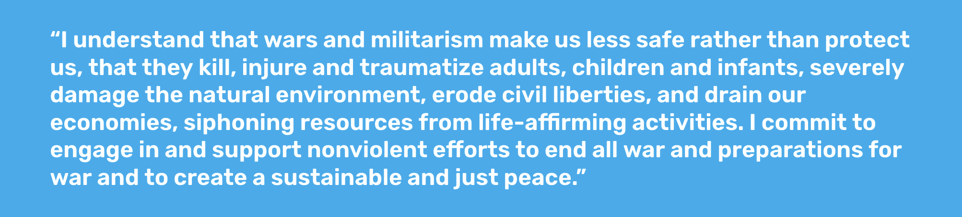
This Declaration of Peace has been signed by many thousands of people in over 190 nations. See worldbeyondwar.org/sign

Why we are now delivering it to ________________________:

